Solutions Michaelmas Term Exercises 2004/2005
Sections in italics are for educational purposes and not required.

Q1.
(a) P(R)=0.08+0.20+0.15+0.08 =0.51 Proportion that use for research

P(E) = 0.08+0.20+0.15+0.16= 0.59 Proportion that use for entertainment

P(R and E) = 0.08+0.20=0.28 , 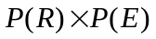=0.3009
Research and entertainment.

As these two numbers are not exactly the same R and E are not independent.

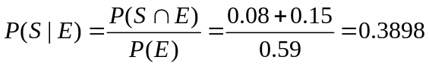

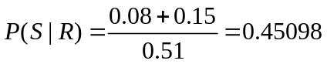

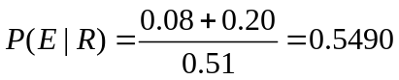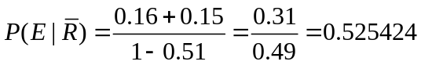
Proportion in R that also use for E Proportion in not(R) that use for E.

E and R are not independent (as above) but the difference is not very big

(b) P(none S) =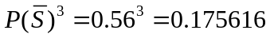

require : P(at least one R| none S) = 1-P(none R|noneS)

(none R) is the complement of ( at least one R)
=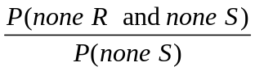

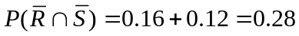 (one individual)

P(none R and none S)=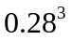

P(noneR|none S)=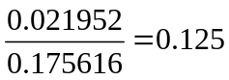 P(at least one R| none S)=0.875

Note could also have 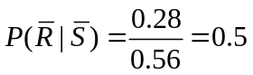 and P(none R | none S)=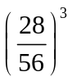=0.125

Q2
Bayes’ rule

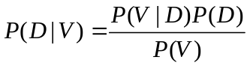

=0.036+0.096=0.132

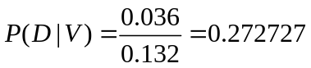

similarly

Probability fails both tests

Independence here means that:

and 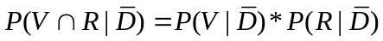

by the partition law

==0.0324+0.00288=0.03528

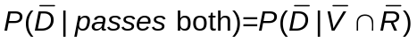

By Bayes’ rule

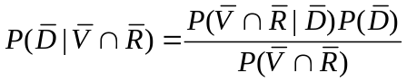

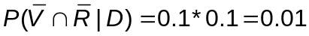

Thus
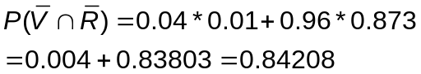

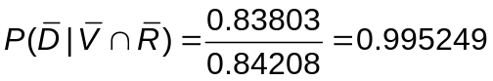

(as in Q1)

 |  |  | D | 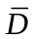
 |  | R | 0.032 | 0.1*0.03*0.96=0.00288
 | V | 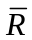 | 0.004 | 0.1*0.97*0.96=0.09312
 | 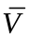 | R | 0.004 | 0.9*0.03*0.96=0.02592
 |  |  | 0 | 0.9*0.97*0.96=0.83808

For  boards
P(V)=0.132 from above= sum of top 4 cells => 0.132-0.032-00288-0.09312
= 0.004

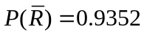 from earlier computation
= (0.004+0.09312+0.83808+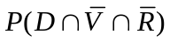)
=0.9352+
Thus =0
Finally P(D)=0.04 so 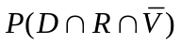=0.004 so that they add up

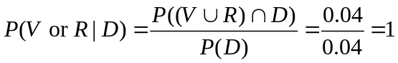

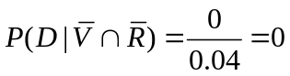

Q3.
(a) The Poisson model applies to random events (occurrences) in time or space . A plank can be regarded as a plane section of the tree – knots are “points” in that plane.
So the basic features of a PP are there. However if knots come in clusters (which they probably do) this would violate the “random” distribution and hence the PP.

P(grade A) = P(X2)=Poisson(2,2,1)=0.6767
P(grade B) = P(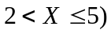=Poisson(5,2,1)-Poisson(2,2,1)=0.9834-0.6767=0.3067
P(grade C)=1 –0.9834=0.0166

The model of the number of grade A in a batch of 15 is Binomial(15,0.6767).
as long as they are independent.

P(Y>7) = )=
=1-0.07529 =0.92471

Bernoulli trials until a success is the geometric distribution

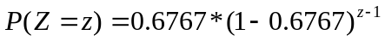 , =0

b)

The discovery of a knot is a bernoulli trial.

If there are X knots in the plank , Y the number of discovered knots is Binomial(X,0.8).
P(at least 4)= =1-0.0104 = 0.9896

Assuming the result
The number of discovered knots is X₁ – Poisson(2*0.8)=Poisson(1.6).
The number of invented knots is X₂ – Poisson(0.2) independent of X₁
As sum of impendent Poissons is Poisson see lectures X₁ + X₂ is Poisson(1.8)

P(grade A)=Poisson(2,1.8,1)=0.7306 slightly more than the true value.

Proof of result.

Numerical demonstration would be via simulation: Simulate Poisson , randomly delete some of the points with prob p. Tabulate the distribution and compare with poisson need at least 5000 sims . Repeat exercise for various values of and p. Not very satisfactory.

Algebraic proof
Have to show that
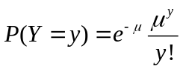 where 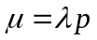

we know that:
If X is the Poisson() random variable then

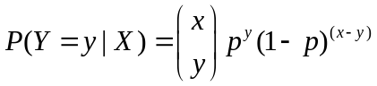

By the partition law and noting that 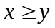 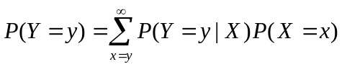

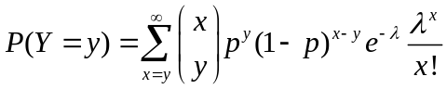

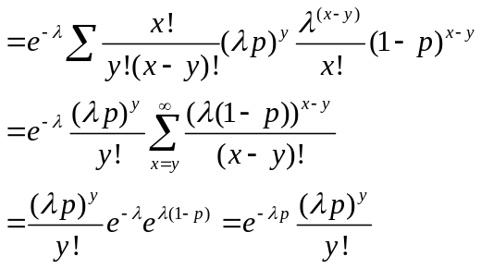

The key issue is to use the partition law.

Q4.
(a).
For exponential 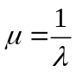 so mean lifetime =3.333 years.
= 0.5488

Want 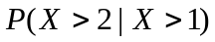 but because of lack of memory of the exponential this is just P(X>1). =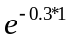 = 0.7408.
Exponential gaps between replacing monitors lead to Poisson Procees.
The number of replacement monitors Y is Poisson with mean = 0.3*3=0.9.
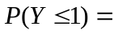Poisson(1,0.9,1)=0.7725. (Note only 1 replacement)

(b)
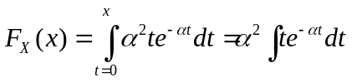

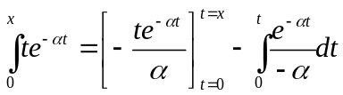 integration by parts

=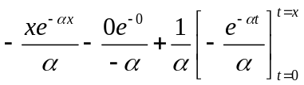

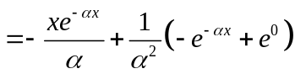
multiplying by 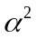 (from first line) gives

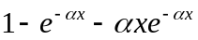 as required.

For Gamma distribution

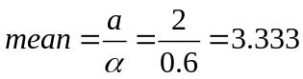

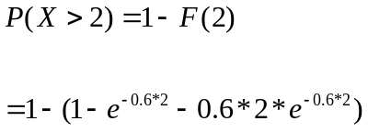

=0.6626

Here cannot use any special properties require:

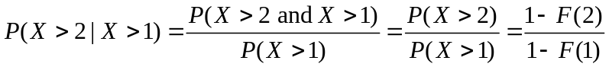

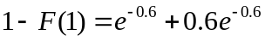= 0.8781

so finally the ratio of these is = 0.7546

Q5.
standard deviation = 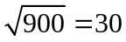

Throughout this Z is N(0,1) ie 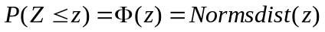

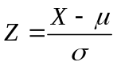

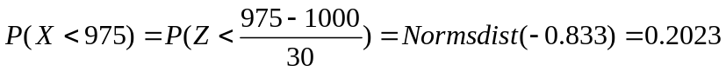
10% of 1000 is 100 so

P(900<X<1100) 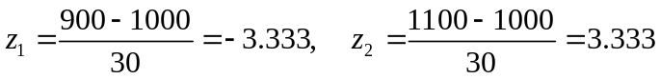

=0.9996-0.0004=0.9992

Note 1 is an acceptable answer here as you tables only go to 3.

(b)
Need Y such that P(-y<Z<y)=0.999

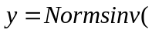0.9995)=3.2905 (3 if using the tables) (0.0005 probability either side)

so 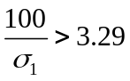 thus 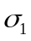<30.39 . (Note it is better than that just.

(c) Sum of normals is Normal.

so R₁ + R₂ is normal mean =1000+1000 = 2000, variance = 900+900=1800.

sd =42.42

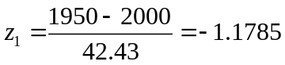 z₂ =1.1785 (-z₁)

probability =0.8807-0.1193=0.7614

10% of 2000 is 200.

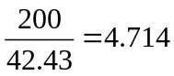

Probality within 10% = 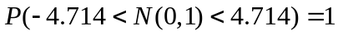

(d) 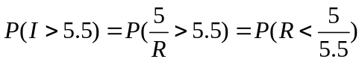=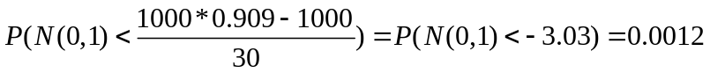
Note again 0 is an acceptable answer.

(e) Mean = 1000+5000 = 6000
Variance = (0.02*1000)² + (0.02*5000)² = 10400
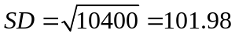

A 95% range is obtained from Normsinv(0.975) =1.959961 , or 1.96, 2 can be used as approximations. see next term

With probability 0.95 R is within
6000 – 1.959961*101.98 to 6000 + 1.959961*101.98 or approximately

6000 – 204 to 6000 + 204

5796 to 6204

Thus the current is in the range :

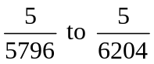

0.000863A to 0.000806A

0.863 mA to 0.806mA with probability 95%

Q6.

Not worth writing a program to answer the question although this is a general epidemic model so it might be used for investigating real situations.

Number the machines 1 to 10 and call the infected machine No 1.
Contacts between non-infected machines are irrelevant so we don’t simulate them.
This will only work if the gaps are exponential.

At time 0 machine 1 is infected.
Time to machine 1 contact with another = X

Using the inverse distribution method
X = -30 * log(RND) = -30 * log(0.88257) = 3.749
logs are base e and using the random numbers row-wise from TLC.

Does it infect the machine contacted ?
Yes if RND <0.8

As RND = 0.689 yes it does.
Not required but
what is the new machine number = 1+ INT(10*RND) = 1+ INT( 10 * 0.217..) = 3
note if this resulted in machine 1 I would try again as machines don’t contact themselves)
So at time 3.749 Machines 1 and 3 are infected.

Next contact
Here we start to create a list of outstanding contacts (messy to program).

Machine 1 will contact at 3.749 + X₁
X₁ = -30 *log(0.278995) =38.297
So contact at 42.046

Machine 3 will contact at 3.749 + X₂

X₂ =-30 *log(0.380009)=29.027

So contact at 32.776

Thus the next event is a contact by machine 3 at 32.776

Machine Number (it might be 1 then no need to see if infection)

= 1+Int(10*RND) = 1+ INT(10 *0.679..)= 7 a non-infected machine

as RND = 0.200944 <0.8 an infection occurs
The 3rd infected is machine 7 at time 32.776

To program this especially for non-exponential gaps need a program structure:

1.Generate times all possible next events (contacts)
2.Find the next event – with the smallest time index.
3. process the next event generating new future events consequent on this
(time of next contact by this machine)
4.Go to 2.

This is called event driven simulation.

(b) Using the data as reflecting relative frequencies.
With modified rejection don’t have to bother scaling them to probabilities just note
that max(f) = 64.
Procedure :
Candidate X = 1+ Int(4*RND) = 1+INT(4*0.661..)= 3
f(3)=64
max(f)*RND = 64 * 0.603.. < 64 so accept the fault is Complete OS failure

Candidate X = 1 + INT(4*0.782) = 4
f(4) = 52
64* 0.072... <52 so accept

fault is Networking fault

